Media Release  7 JUNE 2021 | 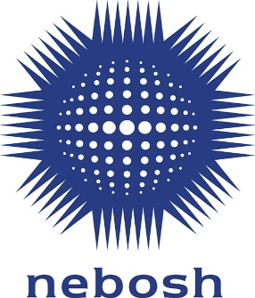
Be part of a sustainable future with the NEBOSH Environmental Management Certificate

Environmental management is key to a successful and sustainable future. NEBOSH has released a new specification NEBOSH Environmental Management Certificate which will help organisation’s to reduce their environment impact and deliver a positive societal impact.

The one-week qualification provides a broad introduction to best practice environmental management. Based around the ISO 14001 management standard, learners will gain technical and practical skills that can be applied to any industry, in any country.

Suitable for people with environmental responsibilities in a low to medium risk workplace, successful learners will be able to evaluate and control a range of environmental issues, work with an environmental management system, contribute to continual improvement and support decision-making with ethical, legal and financial arguments.

Societal impact is key for organisations that want a successful future and business leaders are placing environmental considerations at the top of their priorities; a 2019 Deloitte survey of more than 2,000 global executives indicated that 48% of leaders saw tackling climate change as a top responsibility (38% put encouraging sustainability at the same priority level).

This qualification could help employers to tackle these challenges. It will upskill their people, help meet legal responsibilities, improve reputation and efficiencies and, importantly, reduce their impact on the environment. A two-part assessment process emphasises the practical skills needed in the workplace and learners will be asked to produce a report which assesses environmental aspects and associated impacts for their own organisation.

Hannah Li, NEBOSH Product Developer and environmental specialist, says: “Health and safety professionals are often tasked with environmental responsibilities too; the protection of people, communities and the planet make them complementary functions. The new NEBOSH Environmental Management Certificate will give people a solid technical and practical introduction to the subject, meaning they’re well equipped to make a positive impact in their workplace.”

The NEBOSH Environmental Management Certificate can be studied through NEBOSH’s global network of accredited Learning Partners, offering options for both online and classroom learning. For more information visit: www.nebosh.org.uk/emc

- ENDS -

Notes to Editors

About NEBOSH

NEBOSH is a leading global brand in health, safety, wellbeing and environmental qualifications. Internationally recognised qualifications help to raise the competence of safety and environmental professionals as well as individuals at all levels in the workplace.
Since its inception in 1979 more than half a million people from around the world have studied for a NEBOSH qualification. Tens of thousands join their number every year studying with our network of 600 learning partners in over 132 countries.
NEBOSH qualifications are highly respected by governments, employers and our learners. They build the knowledge and skills which underpin competent performance as a health, safety and environmental professional. NEBOSH qualifications are recognised by all the relevant professional membership bodies.
In 2014, NEBOSH received a Queen’s Award for Enterprise for Outstanding Achievement in International Trade in recognition of our international success.
Contact
For more information please contact:
Jenny Pratt, NEBOSH Head of Communications
jenny.pratt@nebosh.org.uk

